1. Unzip the project zip file located in the same folder at this document
2. Install Android Studio 3.0 (<https://developer.android.com/studio/install.html>)
3. Open in Android Studio by going to File -> Open -> the project folder's location
4. Wait for everything to finish loading
5. Clean the project by clicking on Build -> Clean Project and wait for gradle to complete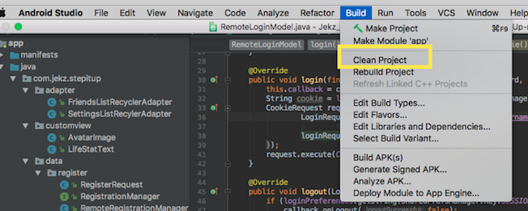
6. Rebuild the project by clicked on Build -> Rebuild Project and wait for gradle to complete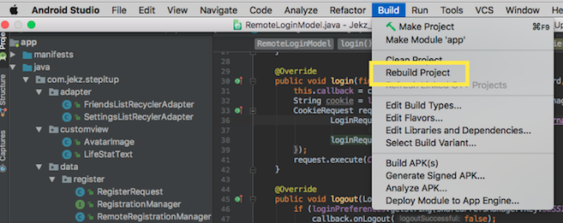
7. Synchronize project with Gradle by clicking on Tools -> Android -> Sync Project With Gradle Files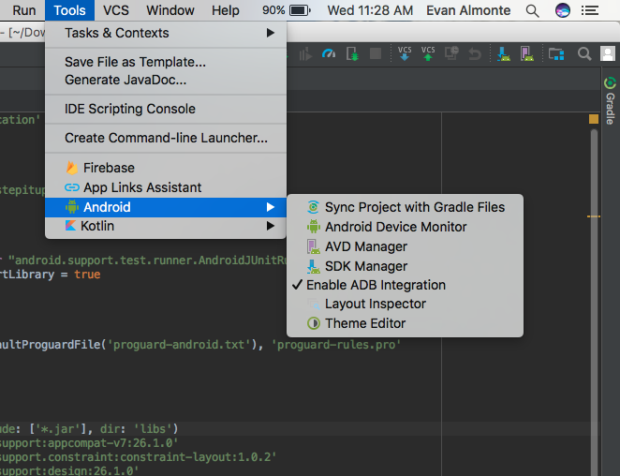
8. Run the app by selecting Run -> Run ‘app’
9. To test on a virtual device:
   1. Select ‘create a new virtual device’ on the select deployment target screen.
   2. Make sure to create a device with API 19 or greater
   3. Select the device and press ‘Ok’
10. To test on an actual device, follow these instructions (Taken from Developer.Android.com):
    1. Connect your device to your development machine with a USB cable. If you're developing on Windows, you might need to [install the appropriate USB driver](https://developer.android.com/studio/run/oem-usb.html) for your device.
    2. Enable **USB debugging** in the **Developer options** as follows.
    3. First, you must enable the developer options:
       1. Open the **Settings** app.
       2. (Only on Android 8.0 or higher) Select **System**.
       3. Scroll to the bottom and select **About phone**.
       4. Scroll to the bottom and tap **Build number** 7 times.
       5. Return to the previous screen to find **Developer options** near the bottom.
    4. Open **Developer options**, and then scroll down to find and enable **USB debugging**.
    5. Run the app on your device as follows
       1. In Android Studio, click the **app** module in the **Project** window and then select **Run > Run** (or click **Run**  in the toolbar).
       2. In the **Select Deployment Target** window, select your device, and click **OK**.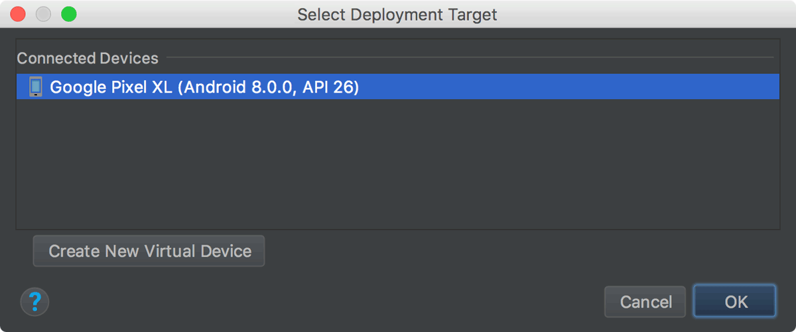
       3. Android Studio installs the app on your connected device and starts it.